2025–26 (Odd): I semester
CAEG Experiential Learning (10 Marks)

USN | Name | Signature
RVCE25BCS
RVCE25BCS
RVCE25BCS
RVCE25BCS

Topic: 3D Model Creation Using Coding

Criteria | Description | Marks
1. Objective Clarity | Clear purpose of the experiment | 2
2. Tools Used | Correct tools listed and relevant | 1
3. Method / Procedure | Steps explained clearly | 3
4. Code Snippet | Relevant and functional code | 2
5. Output & Results | Proper screenshots + meaningful results | 2
 |  | 10

Total Marks Awarded: ______ / 10

Faculty Remarks:

Evaluator Signature: ______________________
OBJECTIVE
The objective of this experiment is to understand how 3D models can be created and controlled using programming rather than traditional drawing or drag-and-drop tools. The experiment aims to use Python and VPython to construct geometric objects based on user inputs and display them in an interactive 3D environment. The focus is on learning how numerical values such as position, dimensions, and color can be used to define the characteristics of 3D shapes.
Overall, the experiment aims to achieve the following goals:
- Create geometric objects such as cubes, spheres, cylinders, cones and gears using Python code
- Use user-provided input to define object position, size, radius, height, and color
- Display all created models in an interactive 3D VPython environment
- Allow selection of any existing object for further operations
- Implement movement controls using keyboard arrow keys
- Implement rotation controls around different axes
- Allow deletion of selected objects
- Demonstrate how menu-driven programs manage repeated tasks in a single execution
- Understand the basics of coordinate-based modeling and real-time 3D visualization
These objectives help introduce the role of programming in engineering graphics and provide a foundation for more advanced work in modeling, simulation, and CAD automation.

TOOLS USED
1. Python 3.x
- Used as the main programming language
- Provides support for logical structures, input handling, and menu-based interaction
- Offers a simple syntax suitable for building graphical applications
2. VPython Library
- Used to render 3D shapes in real time
- Includes built-in functions for creating cubes, spheres, cylinders, and cones
- Supports vectors, lighting, colors, and keyboard interaction
- Generates an interactive 3D window automatically when the program runs
3. Code Editor (VS Code / PyCharm / IDLE)
- Used to write, edit, and test the Python script
- Provides features such as syntax highlighting, auto-indentation, and error detection
- Makes the development process clearer and more organized
4. Terminal / Command Prompt
- Used to run the program and supply all user input
- Handles menu selections, coordinates, dimensions, and color entries
- Displays program output and messages
5. Computer / Laptop
- Used to execute the VPython environment
- Provides the graphics capability required for smooth 3D rendering
- No specialized hardware was needed, as VPython runs on basic systems
These tools collectively enabled the creation of a fully functional 3D object builder using programming concepts and real-time visualization techniques.
METHODOLOGY
1. Environment Setup
- Python and VPython were installed to enable 3D rendering through code.
- A code editor was selected to organize and execute the program.
- A new script file was created to implement the experiment.
2. Importing VPython and Initial Scene Setup
- The VPython module was imported to access 3D shape constructors and vector tools.
- The 3D scene was configured by setting the window title, size, and background color.
- This provided a workspace where all created objects would appear.
3. Creating Data Structures for Object Management
- A list was created to store references to all 3D objects generated in the program.
- Another list was created to store the names of these objects for identification.
- A variable was defined to track the index of the currently selected object.
4. Designing Shape Creation Functions
- Separate functions were written for cubes, spheres, cylinders, and cones.
- Each function requested user input for position, size, radius, height, and color.
- The functions converted user-entered color names into VPython color objects.
- Each function created the corresponding 3D object and stored it in the tracking lists.
5. Writing a Color Helper Function
- A helper function was created to map common color names to VPython color formats.
- A default color was used if an unrecognized color name was provided.
6. Implementing Object Selection
- A function displayed all created objects along with their index numbers.
- The user could enter an index to select an object for further modification.
- The selected index was stored for later operations such as movement or rotation.
7. Implementing Object Deletion
- A deletion function removed the selected object by making it invisible.
- The object was removed from both the tracking lists.
- This ensured that objects no longer in use did not remain active in the program.
8. Adding Keyboard Controls
- A keyboard event handler was added to the VPython scene.
- Arrow keys were used to move the selected object within the 3D environment.
- The “R” and “T” keys were used to rotate the object around different axes.
- These controls provided real-time interaction with objects in the scene.
9. Constructing the Menu Loop
- A continuous menu was displayed using a while loop.
- The menu allowed users to add objects, select them, delete them, or exit the program.
- The loop allowed repeated tasks to be performed without restarting the program.
10. Execution and Verification
- The program was executed and objects were created using various dimensions and positions.
- Movement, rotation, and deletion features were tested to confirm correct functionality.
- The visual output validated the successful implementation of all features.

CODE SNIPPET

from vpython import *

scene.title = "3D Object Builder"
scene.width = 900
scene.height = 600
scene.background = color.gray(0.15)

objects = []
object_names = []
selected_index = None

# COLOR HELPER
def get_color(name):
name = name.lower()
if name == "red": return color.red
if name == "green": return color.green
if name == "blue": return color.blue
if name == "yellow": return color.yellow
if name == "orange": return color.orange
if name == "white": return color.white
if name == "purple": return vector(0.6, 0, 0.8)
print("Unknown color. Defaulting to white.")
return color.white

# SHAPE CREATION FUNCTIONS
def add_gear():
print("\n--- Create Gear ---")
x = float(input("X position: "))
y = float(input("Y position: "))
z = float(input("Z position: "))
radius = float(input("Radius: "))
teeth_num = int(input("Number of teeth: "))
col = get_color(input("Color: "))

gear_parts = []

thickness = radius * 0.2

hub = cylinder(pos=vector(x, y, z), axis=vector(0, 0, thickness), radius=radius, color=col)
gear_parts.append(hub)
# Teeth
tooth_len = radius * 0.4
tooth_width = (2 * pi * radius) / teeth_num * 0.5

for i in range(teeth_num):
angle = (2 * pi / teeth_num) * i

tooth_x = x + radius * cos(angle)
tooth_y = y + radius * sin(angle)

tooth_z = z + thickness / 2

t = box(pos=vector(tooth_x, tooth_y, tooth_z), size=vector(tooth_len, tooth_width, thickness), color=col)

t.rotate(angle=angle, axis=vector(0, 0, 1))

gear_parts.append(t)

objects.append(gear_parts)
object_names.append(f"Gear {len(objects)}")
print("Gear created!")

def add_cube():
print("\n--- Create Cube ---")
x = float(input("X position: "))
y = float(input("Y position: "))
z = float(input("Z position: "))
size = float(input("Size: "))
col = get_color(input("Color: "))
cube = box(pos=vector(x, y, z),
size=vector(size, size, size),
color=col)
objects.append(cube)
object_names.append(f"Cube {len(objects)}")
print("Cube created!")

def add_sphere():
print("\n--- Create Sphere ---")
x = float(input("X position: "))
y = float(input("Y position: "))
z = float(input("Z position: "))
radius = float(input("Radius: "))
col = get_color(input("Color: "))

sph = sphere(pos=vector(x, y, z),
radius=radius,
color=col)

objects.append(sph)
object_names.append(f"Sphere {len(objects)}")
print("Sphere created!")

def add_cylinder():
print("\n--- Create Cylinder ---")
x = float(input("X position: "))
y = float(input("Y position: "))
z = float(input("Z position: "))
radius = float(input("Radius: "))
height = float(input("Height: "))
col = get_color(input("Color: ")

cyl = cylinder(pos=vector(x, y, z),
axis=vector(0, height, 0),
radius=radius,
color=col)
objects.append(cyl)
object_names.append(f"Cylinder {len(objects)}")
print("Cylinder created!")

def add_cone():
print("\n--- Create Cone ---")
x = float(input("X position: "))
y = float(input("Y position: "))
z = float(input("Z position: "))
radius = float(input("Radius: "))
height = float(input("Height: "))
col = get_color(input("Color: "))

con = cone(pos=vector(x, y, z),
axis=vector(0, height, 0),
radius=radius,
color=col)

objects.append(con)
object_names.append(f"Cone {len(objects)}")
print("Cone created!")

# OBJECT SELECTION
def select_object():
global selected_index
print("\nAvailable objects:")
for i, name in enumerate(object_names):
print(f"{i}. {name}")
try:
selected_index = int(input("Enter object index to select: "))
if selected_index < 0 or selected_index >= len(objects):
print("Invalid index")
selected_index = None
return

print(f"Selected: {object_names[selected_index]}")

except:
print("Invalid input")

# DELETE OBJECT
def delete_selected():
global selected_index
if selected_index is None:
print("No object selected.")
return

obj = objects[selected_index]
obj.visible = False
del objects[selected_index]
del object_names[selected_index]
print("Object deleted.")
selected_index = None

# KEYBOARD CONTROLS
def move_or_rotate(evt):
if selected_index is None:
return

key = evt.key
obj = objects[selected_index]

# If object is a gear, move each part
def move_gear(dx, dy, dz):
for part in obj:
part.pos.x += dx
part.pos.y += dy
part.pos.z += dz
def rotate_gear(angle, axis):
# Rotate around the average center of gear
center = vector(0,0,0)
for part in obj:
center += part.pos
center /= len(obj)

for part in obj:
part.rotate(angle=angle, axis=axis, origin=center)
# Check if this is a gear
if isinstance(obj, list):
if key == "left": move_gear(-0.2, 0, 0)
if key == "right": move_gear( 0.2, 0, 0)
if key == "up": move_gear(0, 0.2, 0)
if key == "down": move_gear(0, -0.2, 0)
if key == "r": rotate_gear(0.1, vector(0,0,1))
if key == "t": rotate_gear(0.1, vector(0,1,0))
return
# Normal objects
if key == "left": obj.pos.x -= 0.2
if key == "right": obj.pos.x += 0.2
if key == "up": obj.pos.y += 0.2
if key == "down": obj.pos.y -= 0.2

if key == "r": obj.rotate(angle=0.1, axis=vector(0,0,1))
if key == "t": obj.rotate(angle=0.1, axis=vector(0,1,0))

scene.bind("keydown", move_or_rotate)

# MAIN MENU
while True:
print("\n=========== 3D OBJECT BUILDER MENU ===========")
print("1. Add Cube")
print("2. Add Sphere")
print("3. Add Cylinder")
print("4. Add Cone")
print("5. Add Gear")
print("6. Select Object")
print("7. Delete Selected Object")
print("8. Exit")
print("==============================================")
choice = input("Choose option: ")

if choice == "1": add_cube()
elif choice == "2": add_sphere()
elif choice == "3": add_cylinder()
elif choice == "4": add_cone()
elif choice == "5": add_gear()
elif choice == "6": select_object()
elif choice == "7": delete_selected()
elif choice == "8":
print("Exiting...")
break
else:
print("Invalid choice.")

rate(60)

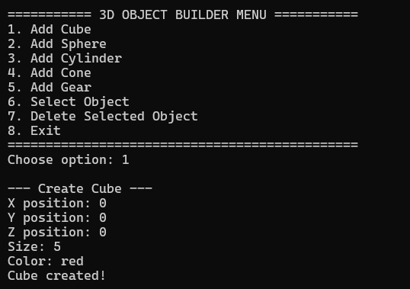
OUTPUT
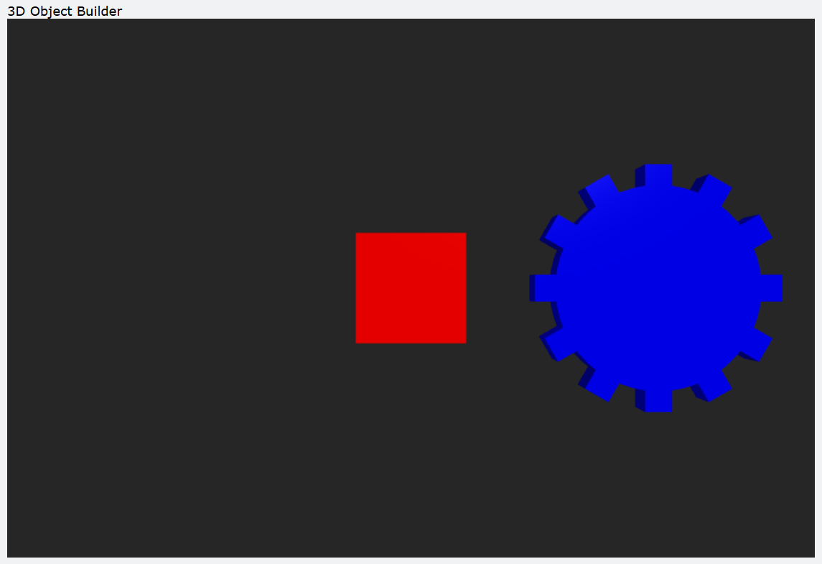
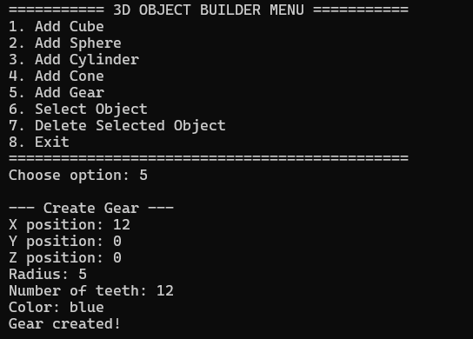
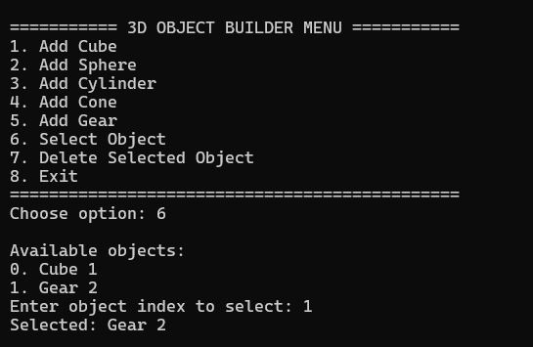
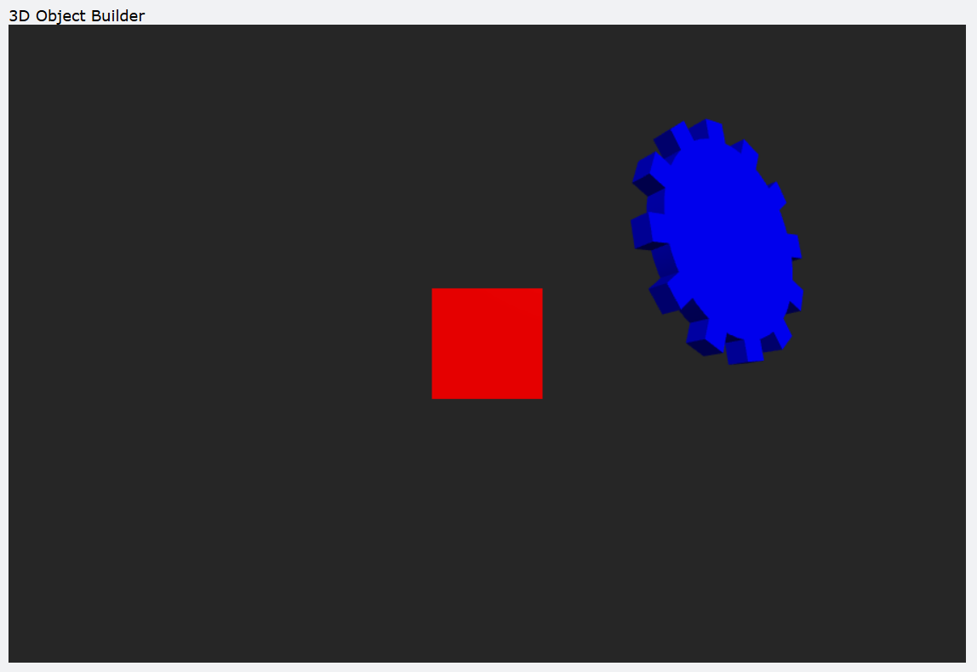
RESULTS
The experiment produced a fully functional 3D object creation and manipulation program using Python and VPython. The results demonstrated that 3D modeling concepts can be implemented effectively using a code-based approach. The outcomes are summarized below:
1. Successful Creation of 3D Objects
- The program generated cubes, spheres, cylinders, and cones based on user inputs.
- Objects appeared correctly in the VPython window with the specified dimensions, positions, and colors.
- The shape creation functions worked consistently throughout execution.
2. Accurate Handling of User Inputs
- The program correctly processed all coordinates, dimensions, and color values entered through the terminal.
- Error messages were shown for invalid inputs, keeping the program stable.
- The color helper function mapped common color names correctly.
3. Functional Object Selection System
- All created objects were listed with index numbers for easy identification.
- The selection function allowed any object to be chosen for further modifications.
- Movement and rotation reflected which object was currently selected.
4. Real-Time Object Manipulation
- Arrow keys enabled smooth movement of the selected object along the axes.
- “R” and “T” keys rotated the object around the Z and Y axes.
- VPython updated the display continuously, providing real-time visual feedback.
5. Object Deletion
- The delete function removed selected objects from the 3D scene and internal tracking lists.
- Remaining objects were unaffected and continued to function normally.
- List and memory handling remained consistent.
6. Stable Interactive Menu System
- The menu allowed repeated creation, modification, and deletion of objects.
- All menu options executed smoothly without unexpected behavior.
- The program remained responsive during the entire session.
7. Overall Outcome
- The experiment demonstrated the use of programming to construct and control 3D models.
- The results showed that code-based modeling provides flexibility and precision similar to basic CAD operations.
- The final program forms a suitable base for future graphics or modeling projects.

